Project 1. Dots & Lines
Specs and Guidelines
The purpose of this assignment is to engage students in noticing the many roles dots and lines undertake as the most basic elements in a visual composition. Students will learn to deconstruct the visual media surrounding them—improving their visual literacy. This project is used to assess the students’ understanding of the dot and line as compositional elements with formal and symbolic values.

Goals
- You will create a file in Adobe Illustrator and save it as a native (.ai) file and PDF, which is appropriate for printing and sharing.
- The AI document should be 8.5 by 14 inches.
- The document will display 3 compositions:
  - Original: a composition downloaded or scanned from a public media source of your choice
  - Dots: a copy of the original that emphasizes dots used throughout the composition
  - Lines: a copy of the original that emphasizes straight lines used throughout the composition.
- You will create a system for categorizing the dots and lines by their conceptual roles: foreground elements, background elements, and symbolic elements (such as the use of a formal element to indicate an idea).
- The original composition can be an advertisement, a photograph, a film still, or an animation frame (the latter two may be screen shots from the web, such as a screen shot of a video posted on YouTube). See the sample on the next page.

RESEARCH
Digitize or download any published composition of your choice. You can search on the web or scan a printed publication. Your composition must include at least 100 dots or 100 lines or 50 of each. In other words, the composition you choose must be complicated enough for you to practice via repetition for this project. A minimalist composition is not acceptable.

download or scan and save your reference files
Scan or download your original composition at 72 DPI and save it as a JPEG or PNG file. Name the original image original and include the extension, such as original.jpg.

ADOBE ILLUSTRATOR
- Place the composition in Illustrator and create two additional copies of it on a layer named original (see Chapter 2).
- Create new layers with the following names for the necessary categories (you may not need a symbolic layer for both lines and dots): line-foreground, line-background, line-symbolic, dot-foreground, dot-background-dot-symbolic, contrast, and original image.
- Use the Pencil and/or line tool to create lines (see Chapter 2) and the Ellipse tool to create dots (see Chapter 1).
- Create a rectangular shape on top of the two copies of the original composition and set the shape with a black fill and 70% transparency (use the Transparency panel). This will help you to create contrast so your work is easier to view.
- Fit all compositions side by side or one on top of the other in your document. The arrangement is part of your presentation. Use File > Save As to save the file in native format and as a PDF.
- Create a legend or key that explains how you have organized the different types of dots and lines in the composition.
- Create an area on the page in which you provide information about the source image (a URL or some other way of citing the publication).

NAMING AND SUBMITTING YOUR FILES
You will be submitting two digital files in a single, compressed ZIP file, including the native file and a PDF of your compositions. Use your last name-first initial when naming your AI and PDF files. Follow standard naming conventions (see Chapter 2). Archive both files to produce one ZIP file (see the Archiving and Uploading screencast).
Each student is responsible for submitting one archived ZIP file named last name-first initial.zip (for example, burrough-x.zip).
{Project 1 Specs and Guidelines}

Grading Rubric (10 points, total)
See the table below for the Project 1 point system.
Elements of Composition | Goals | Points
Aesthetics | How do your compositions compare to the originals? Could you have used about fifty more lines or dots to represent the elements with greater accuracy? Did you over-complicate the design with too many strokes (ie. including circles that are part of other shapes in one of your dots layers)? | 5
Technique | Earn up to one point for demonstrating a mastery of skills learned in the chapters. Earn two points for following directions and organizing your layers properly. Earn two points for following file naming and submission guidelines. | 5
 | Total Points Possible | 10
Grading Rubric, Project 1

Here is a samplE: notice my layers panel and transparency applied to the contrast layer.

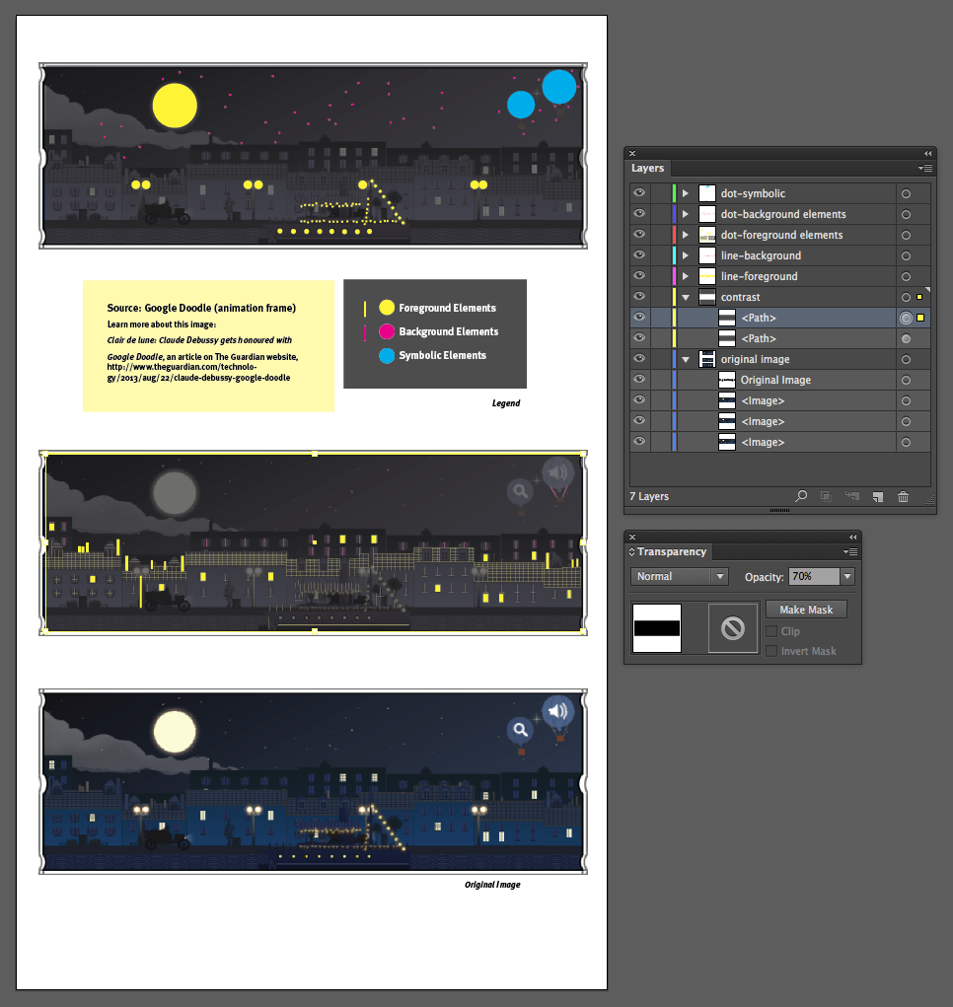

Project 2. Event Photography
Specs and Guidelines
The purpose of this assignment is threefold: to assess students’ understanding of how symmetry and asymmetry can be used in a composition to influence the visual message in a photograph; to provide students with the opportunity for editing their own work; and to assess students’ compositional skills in photographic images.

goals
You will submit at least 36 attempts at the final two submissions: an asymmetrically balanced slice of life (candid) portrait of a person or group of people and a reflectively balanced, symmetric portrait of a person or people that illustrates an idea (metaphor).

Specifications
- Shoot at least 36 images of a single daytime, outdoor, public* event in order to achieve the following:
  - An asymmetrically balanced slice of life (candid) portrait of a person or group of people. The subjects should appear unaware of the camera.
  - A reflectively balanced, symmetric portrait of a person or people that illustrates an idea (metaphor).
- Transform all 36 images to grayscale mode (you may shoot in grayscale or color, then shift the color mode, if you need to, during post-production).
- Create a PDF showing all 36 grayscale images.
- Select your two final images meeting the goals in 1a and 1b.
- Edit your final two images in Photoshop (see Chapter 8) to achieve a full tonal range and contrast in the mid-tone range.
*A public event will be listed in the calendar section of the newspaper. Sporting games, farmer’s markets, rallies, protests, and so on are public events. Weddings, birthday parties, your friends on a shopping trip or at the park are not public events. You can bring a friend to pose for the metaphor image but you will be taking photos of strangers for the candid shots.

guidelines for shooting
Set your ISO rating and aperture/shutter speed before starting your shoot. The aperture and shutter speed will change throughout the shoot and some students’ cameras will not offer control over these operations. This is OK—watch for an exposure value shift and control that (maybe with plus and minus buttons) if you can. If you have few or no controls, shoot outside when there is plenty of light. Do not shoot at noon (the worst lighting situation for a new photographer is deep shadows and bright highlights, common to noon lighting). Keep your goals in mind while you are shooting.

submission guidelines
Deliver three items: the PDF and two separate JPG images, as follows:
- The PDF of 36 images in total should show your attempts at satisfying the goals of this photographic project (use Bridge, see Chapter 4).
- Each image should appear on a single page with the file name visible beneath it.
- Name your files your last name-first initial followed by a two-digit sequence number and the file format (ie. burrough-x01.jpg, burrough-x02.jpg, and so on).
- Name the PDF your last name-first initial.pdf (ie. burrough-x.pdf).
- Note: You can bracket, change positions of your subjects (metaphor photo), change your point of view (candid shot), and so on. You do not need to have 36 original ideas. You only need 1 idea for the metaphor image!
- The two final JPG images (one for each goal) should be named your last name-first initial-candid.jpg and last name-first initial-metaphor.jpg (ie. burrough-x-candid.jpg, burrough-x-metaphor.jpg).
- Archive all three files in one ZIP file to submit your project.
{Project 2 Specs and Guidelines}

Grading Rubric (10 points, total)
See the table below for the Project 2 point system.
Submitted File | Goals | Points
PDF File | 36 grayscale images following the specified naming conventions and file format | 1
Final Slice of Life (Candid) Photograph | Asymmetric balance is achieved | 2
 | The photographer is close enough to the action that no cropping is required | 1
 | The tonal range is full and contrast is achieved (no hot spots, shadows don’t fall black) | 2
Final Metaphor (Symbolic) Photograph | Reflective, symmetric balance is achieved | 1
 | The photographer creates a clear and obvious message using metaphor or symbolism | 2
 | The tonal range is full and contrast is achieved | 1
 | Total Points Possible | 10

Project 3. Editorial Illustration for a News or Magazine Article Specs and Guidelines
The purpose of this assignment is to assess the students’ abilities to create a coherent visual message relating to a news or magazine article using juxtaposition and repetition.

Goals
Create an 11 by 14 inch collage for print resolution (300 DPI) that illustrates the article assigned in class. Use your own images whenever it is possible. Use images protected by a Creative Commons license or in the Public Domain to supplement your images. Use copyright protected images only if you are commenting upon or parodying the original.

Specs
- The original file size is 11 by 14 inches at 300 DPI
- Use Photoshop layers to create a collage
- You can use images and type, but focus more on images in this project
- You should use layer masks for non-destructive editing
- Repeat elements to create continuity, and break the repetition to create contrast
- Do not use (or use sparingly) type at this time (you will add typographic elements later)
- When you are finished save the file in PSD format to save your native file with editable layers. Then, choose File > Save As to save a copy of your file in JPG format. This will flatten your layers and compress the file so that the file size is smaller and a viewer can access the image on any computer using a web browser or Preview application.
- Finally, set the resolution to screen resolution (72 DPI). Your document will decrease in size dramatically. That’s OK. Save a third copy of your file named lastname-first initial-lowres.psd.

SUBMIT YOUR FILE
Submit just the low-resolution PSD file and the high resolution JPG file. Name the ZIP archive of your files: your last name-first initial.zip (ie. burrough-x.zip) and use this naming convention for the two files archived.
{Project 3 Grades and Specs}

Grading Rubric (10 points, total)
Elements of Composition | Goals | Points
Aesthetics | How does your collage use visual design principles that unify the composition to help readers understand your message? | 4
Concept | The article should be expressed clearly. Does your illustration simply relay the title of the article or can the viewer gain more insight into it due to the images you selected and your method of juxtaposition? Were you able to use all of your own images or find images with a distribution license accessible to you? Did you use the fair use clause of the US copyright law to appropriate any copyright protected material that you may have used? | 4
Technique | Earn one point for demonstrating a mastery of skills learned in the chapters and screencast and one point for following directions. | 2
 | Total Points Possible | 10
Grading Rubric, Project 3

Project 4. Typography Web Project w/ Tschichold Specs and Guidelines
The purpose of this assignment is to assess student understanding of the significance of the grid in typographic design following Tschichold’s doctrine in New Typography.

goals
Develop a layout for a single web page showcasing just one product that you can purchase from Ikea. Take a stance and glorify or diminish one Ikea product.

specs
- Create your layout in Adobe Illustrator. The web page design should be no more than 960 pixels wide. It can be between 560 and 1000 pixels tall. The file resolution should be fit for the screen, meaning you should be working at 72 DPI in RGB color mode (if you choose the “Web” profile in Adobe Illustrator you will create a profile at 72DPI in RGB color mode).
- The web page should consist of a logo, navigational tool bar, footer area, and main content area with text and/or images as follows: first class of hierarchy (the site identity and either a headline, a product name, or a page name or subsection), second class of hierarchy (subhead, price, headline within a subsection, etc.), third class of hierarchy (text, product details, and so on), and fourth class of hierarchy (small type or fine print).
- The composition of the web page design should be asymmetrically imbalanced.
- Create activate negative space.
- Use a line of continuation to make a visual connection between separate classes of text or body copy (ie. by using guides in your document).
- Use only one sans serif font family, with as many variations as you can to create contrast. The following typefaces are examples of a sans serif font you may have installed on your computer: Helvetica, Arial, Verdana, Universe, or Gill Sans.
- Use only black, white, and one hue.
- Use the color in your composition as a navigational tool to direct the viewer’s eye.
- Develop columns of type with legibility in mind.
- Create as much contrast as you can to develop a focal point.
- You may use photographs, but be sure to pay attention to asymmetry and imbalance within the composition.
- If you use a photograph, either set it in black and white or in a monochrome color to match the hue you selected. (Use Photoshop to modify any images you place in the Illustrator document).

STEP 1: MAKE A PLAN
What is your plan for creating visual hierarchy? What should the reader see first?

STEP 2: Submit A DRAFT, GET FEEDBACK
You will be submitting your draft in JPG format (choose File > Save for Web to save a JPG file in Illustrator). Feedback will be provided. Submit notes regarding revisions you will make to your design and attach the first draft of the page design (in JPG format) to your message.

STEP 3: revise YOUR project
While revising your project, revisit the notes you posted. Often times new (and old) designers will stray from their intentions while working on a project, getting caught up in the moment of making and forgetting overall themes and goals.

Step 4: SUBMIT YOUR WORK
Submit a final archive file that includes your Ai and a JPG of the design. Name it your last name-first initial.zip (burrough-x.zip). Name your individual files as well (ie. burrough-x.ai, burrough-x.jpg), following standard naming conventions.
{Project 4 Goals and Specs}

Grading Rubric (10 points, total)
See the table below for the Project 4 point system.
Tschichold’s Principles | Goals | Points
Asymmetry | Divide your composition into quadrants. If you have content in more than two quadrants, your composition is probably not asymmetric. | 2
Meaningful Use of Color | You will use only one color in addition to black and white in this composition. Use the color to navigate the eye throughout the hierarchies in the design. | 2
Positive Deployment of Negative Space | Watch out for “dead” space. All of the negative space should be active. | 2
Exploit Contrast | Use contrast to group chunks of data. Large headlines should be set above or alongside tiny lines of typography. Use at least three type sizes. Use as many variations as you can. Watch for contrast in all things, including the negative space. | 2
Lack of Interest in Visual Balance | The composition should not only be asymmetric, but it should also be imbalanced. Do NOT create point and counterpoint. Create just point—no counterpoint. Yes, it will feel wrong. If it feels wrong, you probably got it right. | 2
 | Total Points Possible | 10
Grading Table for Project 4

Project 5. Revise & Create Specs and Guidelines
The purpose of this assignment is to assess the students’ abilities to add typography to an illustration that creates unity and hierarchy, is legible, and supports the concept of the article supported by the type-image graphic.

Goal
An 11 by 14 inch optimized PDF displaying the collage created in Project 3 with the associated typography in place.

SPECS
- You may revise the collage, but you must continue to work with the concept and images you originally used. You should not need to throw away the old file and start anew. Doing so will result in a penalty.
- When you are finished working on the image, save it as a PSD file and import it to an 11 by 14 inch Illustrator document.
- Add the article section name, headline, and byline to the collage you created for Project 3 using Adobe Illustrator. Typography (a vector graphic) prints better from Adobe Illustrator than from Photoshop.
- Be attentive to your typographic treatment. Adjust kerning, leading, and size if your composition requires these adjustments. Create unity and contrast through value, color, size, and/or variation.
- When you are finished, save an optimized PDF for viewing on the web. Images will be down-sampled to between 72 and 150 DPI (sometimes they just don’t look great at 72 DPI—you can decide on the file resolution).
- Also save a JPG of your final Photoshop collage file for submission.

SUBMIT YOUR FILE
Submit a ZIP archive (last name-first initial.zip) of your final JPG and optimized PDF file.
{Project 5 Goals and Specs}

Grading Rubric (10 points total)
Type-Image Relationship | Goals | Points
Aesthetics | How does the relationship between the typography and the collage use visual design principles to unify the composition and help readers understand the message? | 4
Concept | The article should be expressed clearly. Does your typography treatment relay the title of the article or can the viewer gain more insight into it due to the typeface selection and unification of type to image? Did you ditch your first attempt and start all over again? | 4
Technique | Earn one point for demonstrating a mastery of skills and one point for following directions. | 2
 | Total Points Possible | 10

